

NOTRE DAME UNIVERSITY
BANGLADESH
Assignment No. 03
Submitted by:
Name: Istiak Alam
ID: 0692230005101005
Batch: CSE-20
Course Title: Database Management Systems
Course Code: CSE-2206
Assignment No: Practice MySQL-4
Submission Date: 23-04-24
Assignment Topic: (a) Create Database
(b) Create Tables
(c) SQL Queries

Submitted to:
Fernaz Narin Nur
Associate Professor, NDUB

- Create the following table ‘order’ in your database.

ord_no | purch_amt | ord_date | customer_id | salesman_id
70001 | 150.5 | 2021-10-05 | 3005 | 5002
70009 | 270.65 | 2021-09-10 | 3001 | 5005
70002 | 65.26 | 2021-10-05 | 3002 | 5001
70004 | 110.5 | 2021-08-17 | 3009 | 5003
70007 | 948.5 | 2021-09-10 | 3005 | 5002
70005 | 2400.6 | 2021-07-27 | 3007 | 5001
70008 | 5760 | 2021-09-10 | 3002 | 5001
70010 | 1983.43 | 2021-10-10 | 3004 | 5006
70003 | 2480.4 | 2021-10-10 | 3009 | 5003
70012 | 250.45 | 2021-06-27 | 3008 | 5002
70011 | 75.29 | 2021-08-17 | 3003 | 5007
70013 | 3045.6 | 2021-04-25 | 3002 | 5001

Creating Table Students
- Create the following table ‘customer’ in your database.

customer_id | cust_name | city | grade | salesman_id
3002 | Nawab Salimullah | Dhaka | 100 | 5001
3007 | Abdul Halim | Dhaka | 200 | 5001
3005 | Purna Das | Comilla | 200 | 5002
3008 | Shamsul Huda | Chottogram | 300 | 5002
3004 | Surya Sen | Bogra | 300 | 5006
3009 | Haji Sharatullah | Khulna | 100 | 5003
3003 | Pritilata Waddedar | Sylhet | 200 | 5007
3001 | Abdus Salam | Chottogram | 400 | 5005

- Create the following table ‘salesman’ in your database.

Ans:
salesman_id | name | city | commission
5001 | Nasima Akhter | Dhaka | 0.15
5002 | Amit Chakma | Bogra | 0.13
5005 | Azizul Haque | Chottogram | 0.11
5006 | Tanzima Hoque | Bogra | 0.14
5007 | Fazle Hossain | Barisal | 0.13
5003 | Zahid Hasan | Mymensingh | 0.12
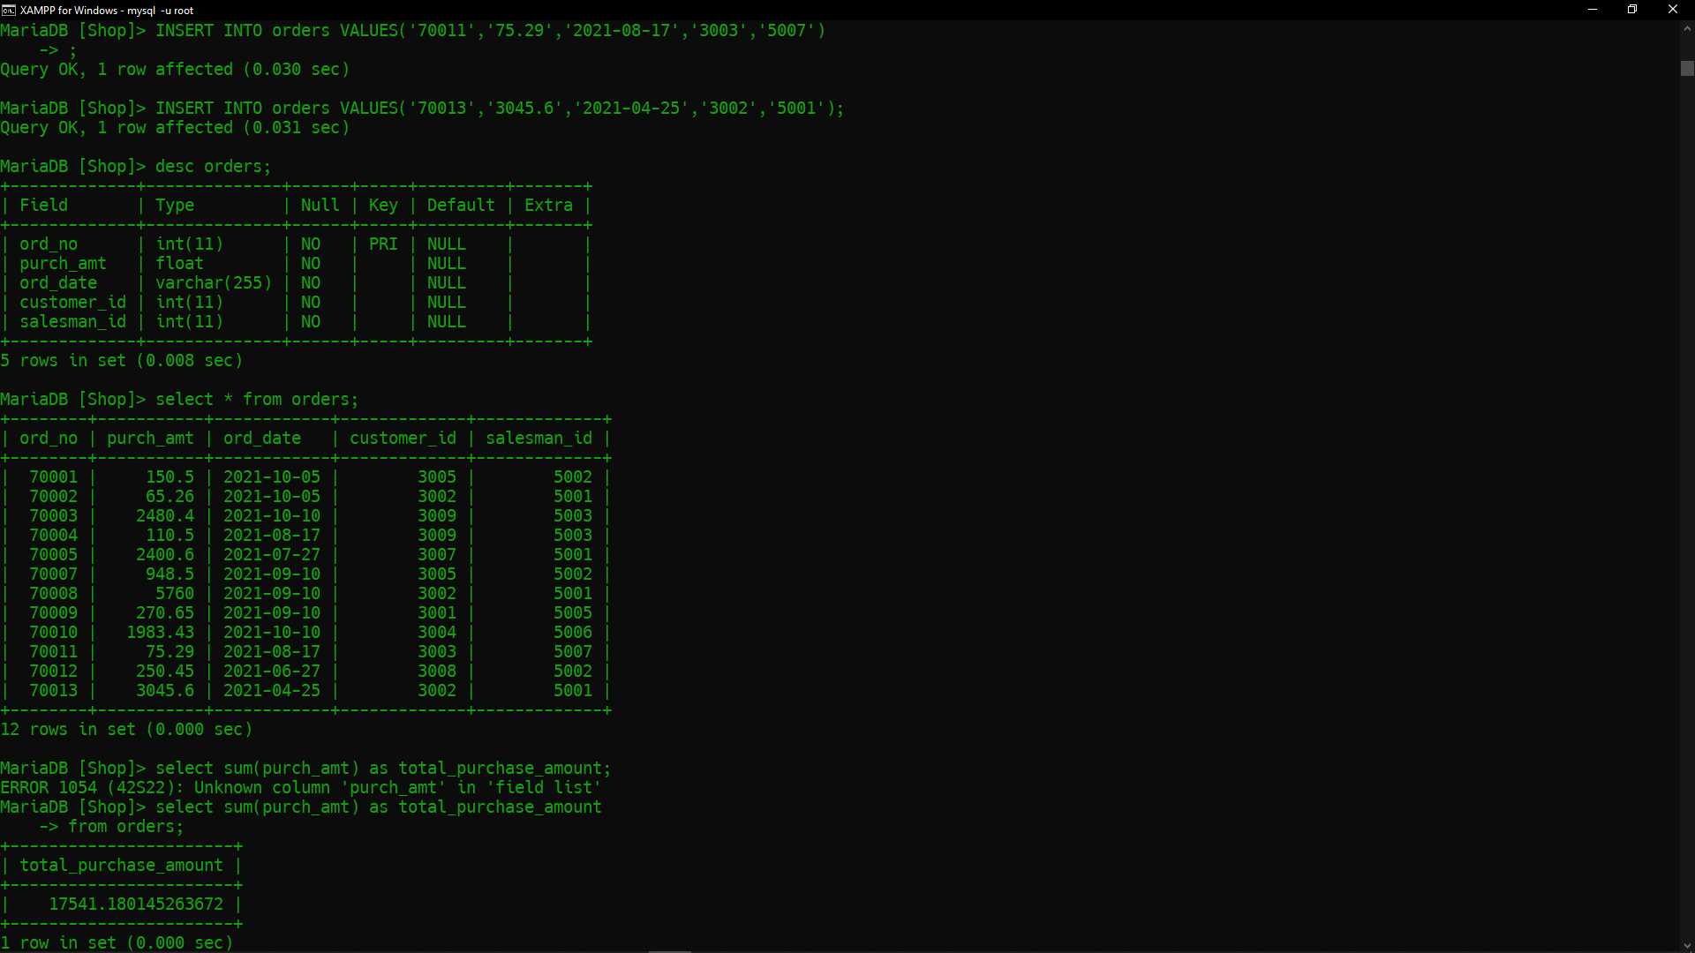
Table: Orders

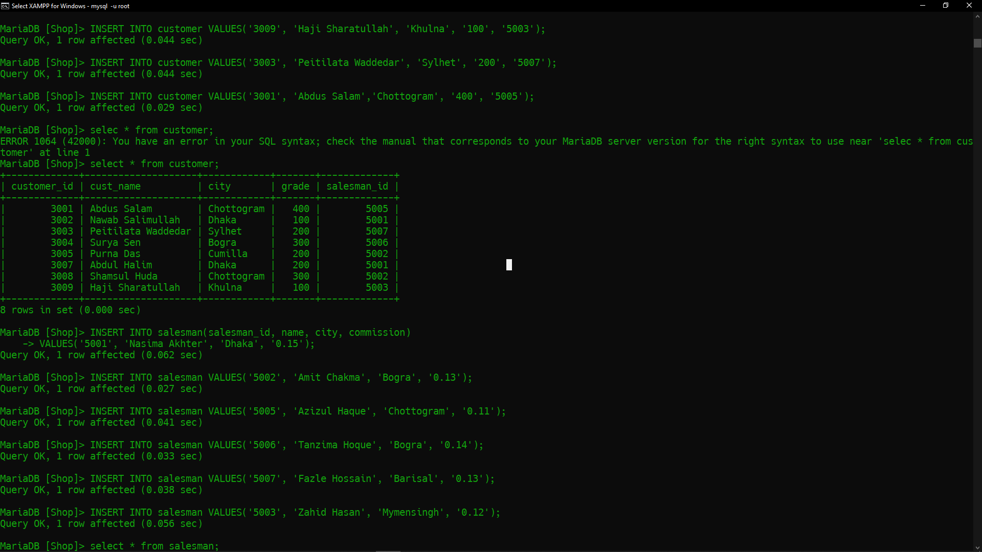
Table: customers
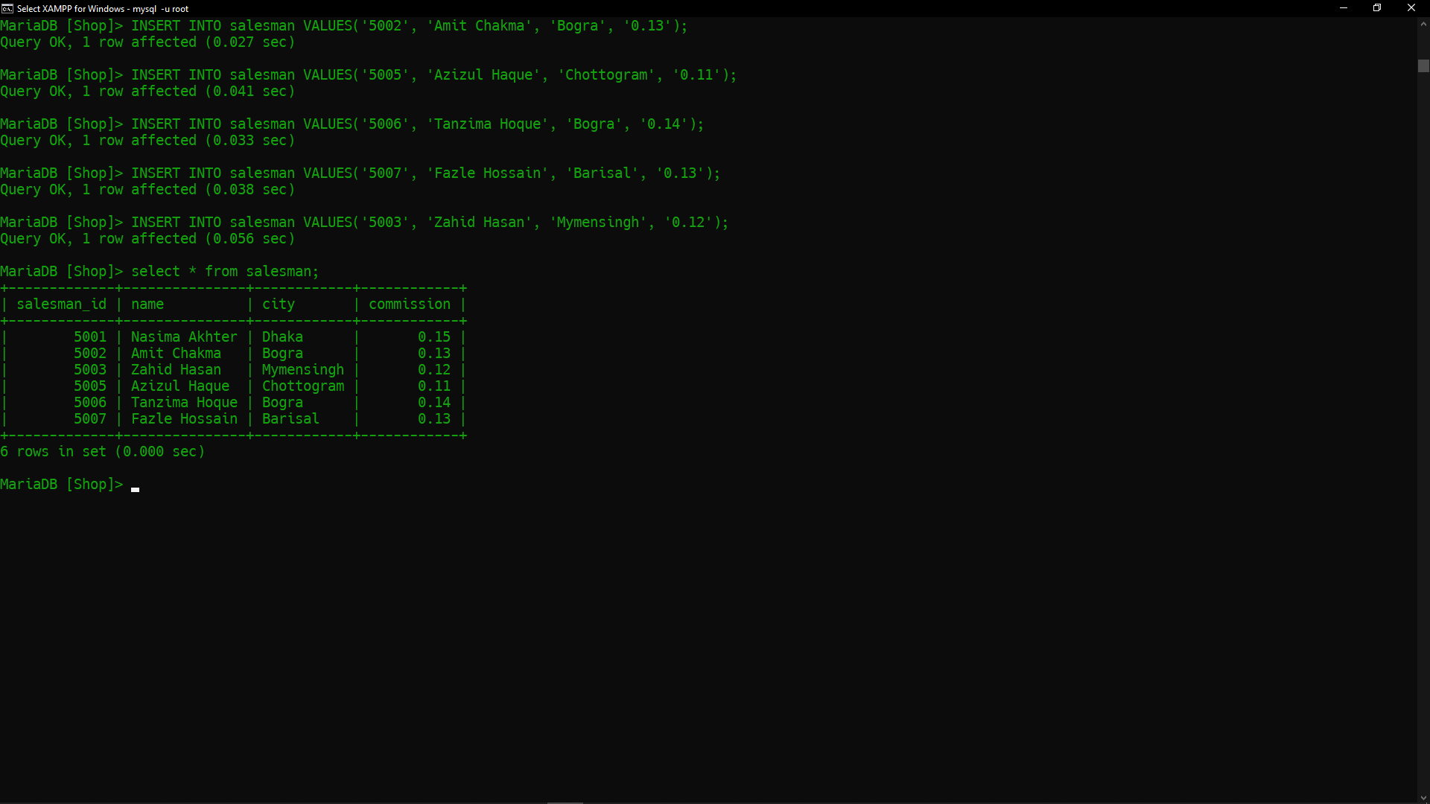
Table: salesman

Answer the following queries with this table:
- Write a SQL statement to find the total purchase amount of all orders.
Ans: -> SELECT SUM(purch_amt) AS total_purchase_amount
-> FROM orders;
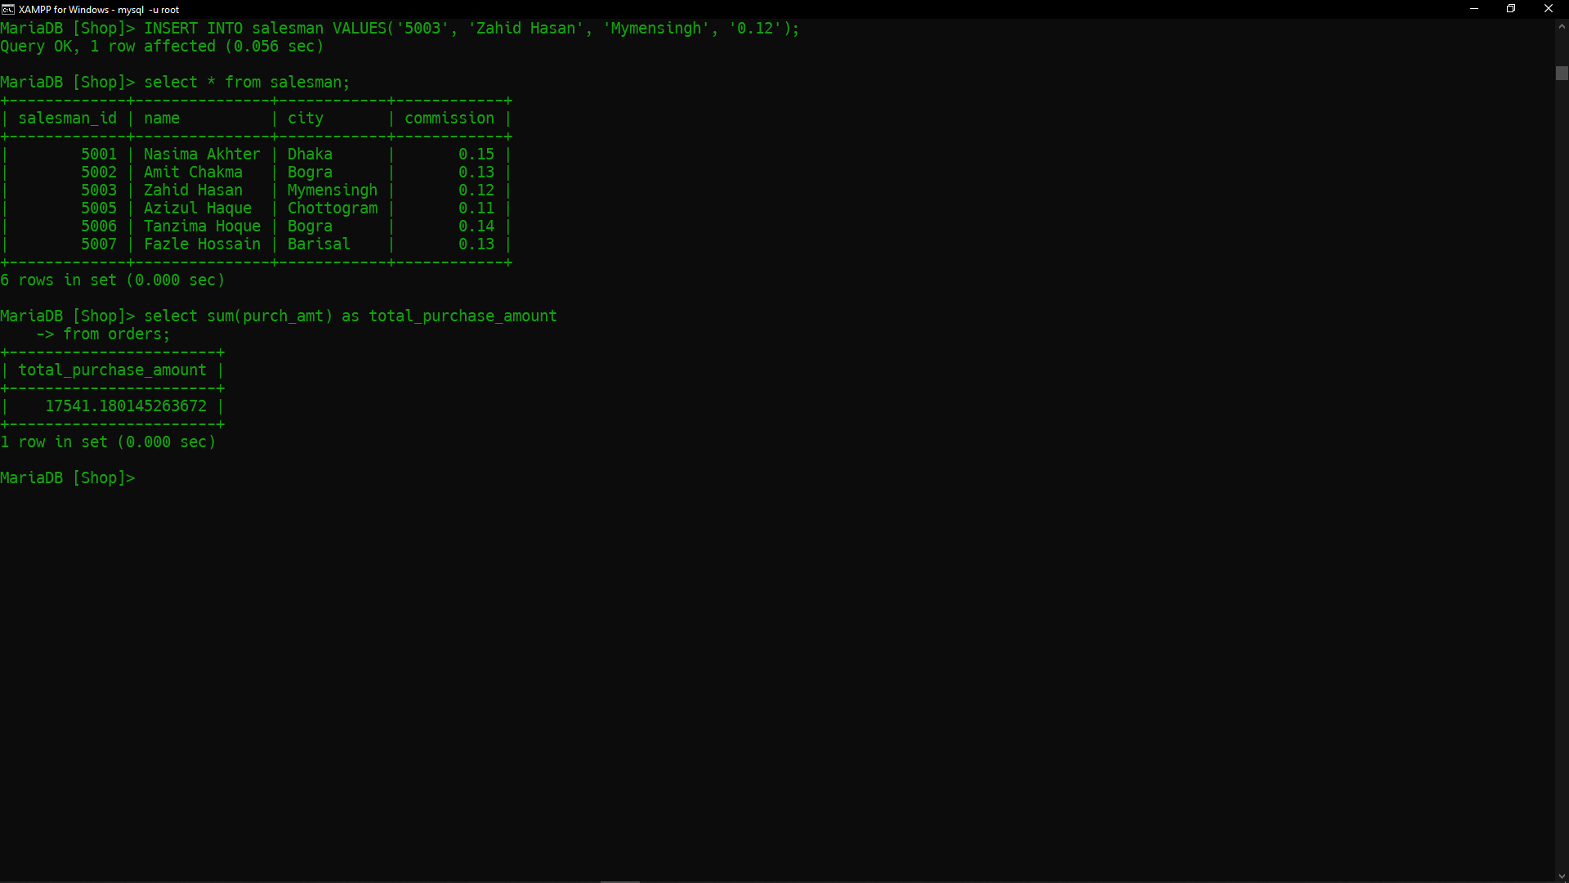

- Write a SQL statement to find the average purchase amount of all orders.
Ans: -> SELECT AVG(purch_amt) AS average_purchase_amount
-> FROM orders;
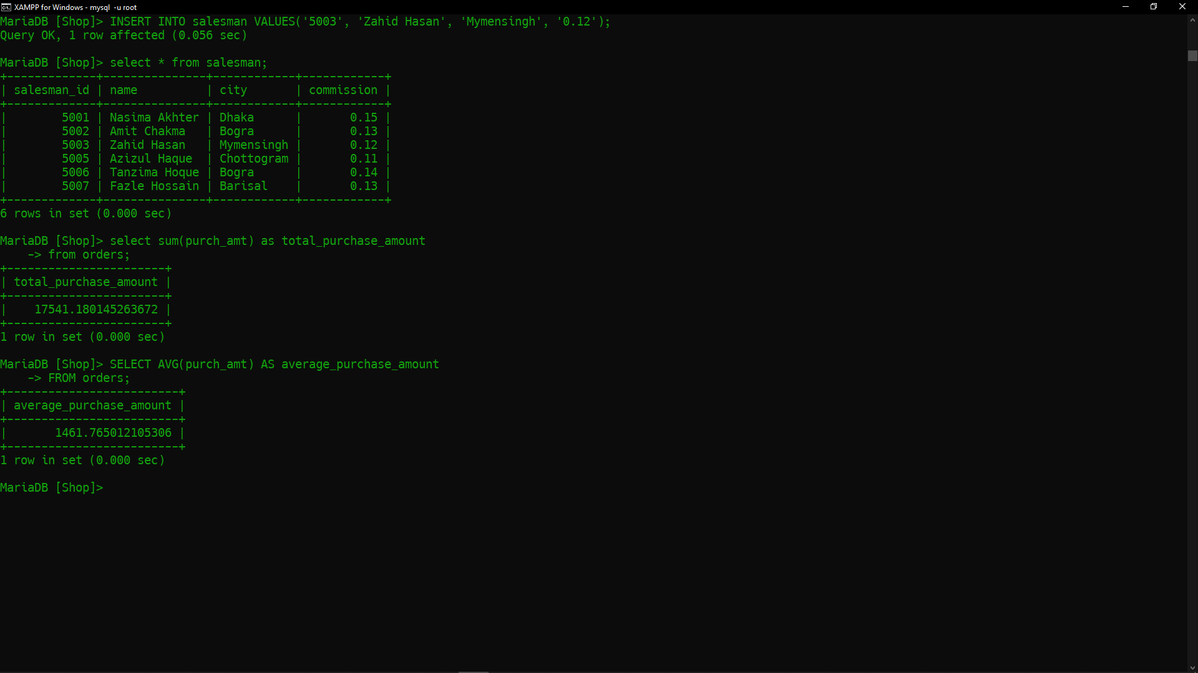

- Write a SQL statement to find the number of salesmen currently listing for all their customers.
Ans: -> SELECT COUNT(DISTINCT salesman_id) AS number_of_salesman
-> FROM customer;
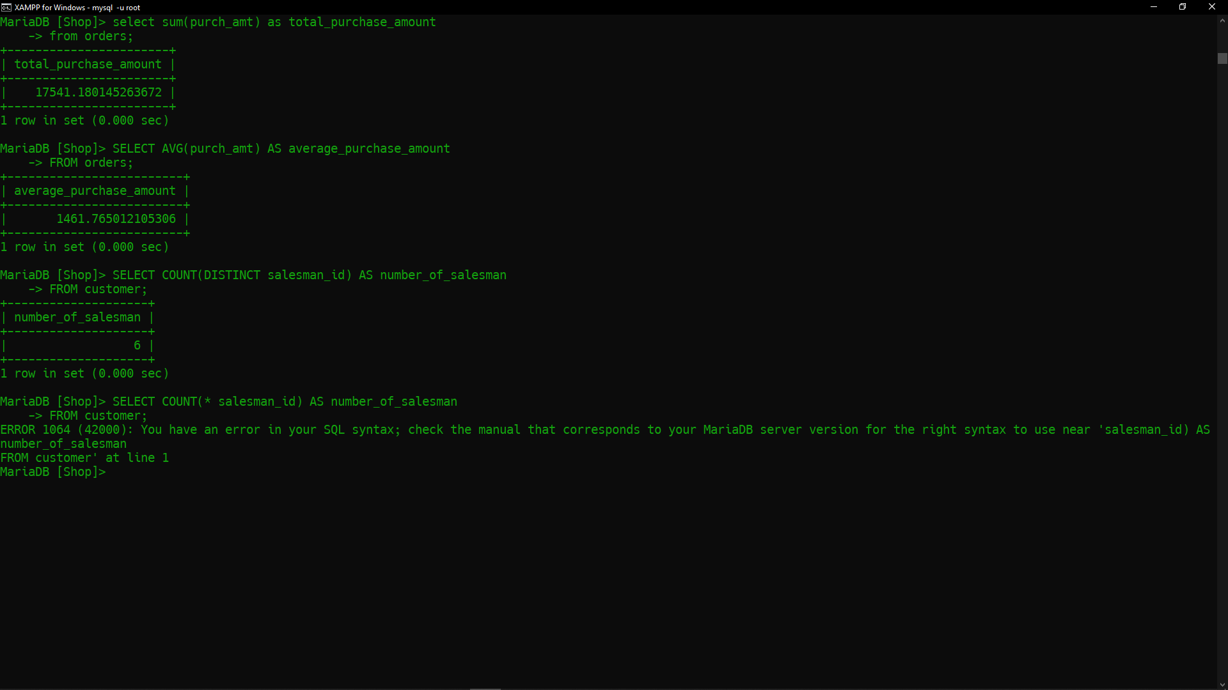

- Write a SQL statement know how many customer have listed their names.
Ans: -> SELECT COUNT(DISTINCT customer_id) AS number_of_customers
-> FROM customer;
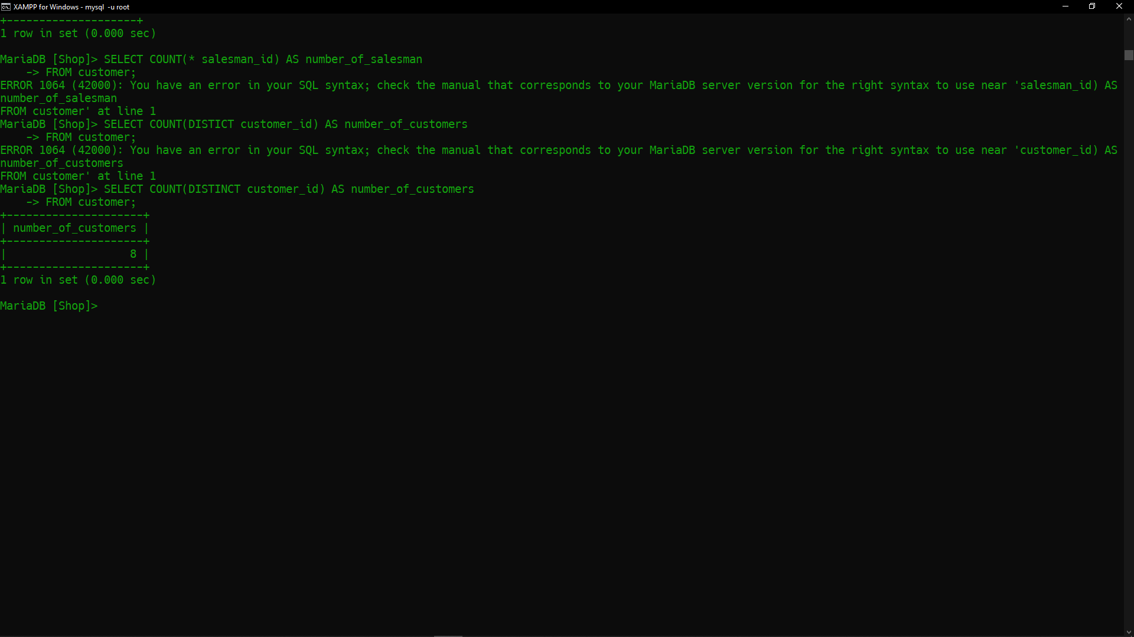

- Write a SQL statement find the number of customers who gets at least a gradation for his/her performance.
Ans: -> SELECT COUNT(DISTINCT customer_id) AS number_of_customers
-> FROM customer
-> WHERE grade IS NOT NULL AND grade > 0 ;


- Write a SQL statement to get the maximum purchase amount of all the orders.
Ans: -> SELECT MAX(purch_amt) AS max_purchase_amount
-> FROM orders;
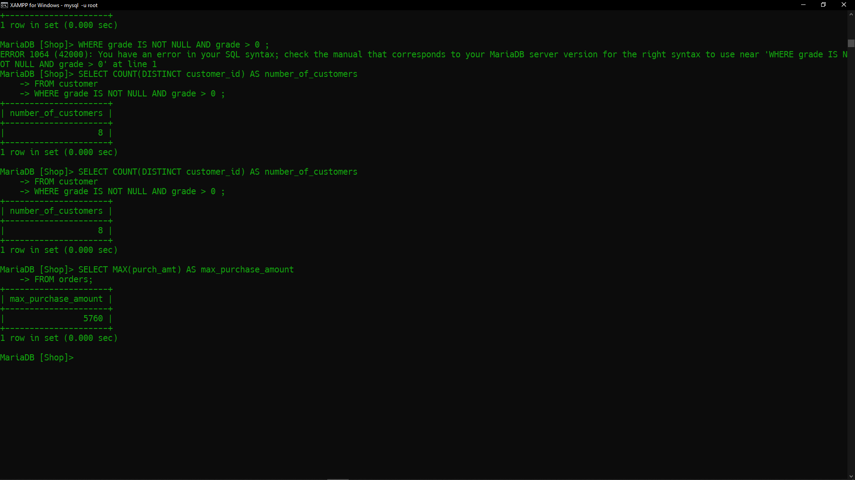

- Write a SQL statement to get the minimum purchase amount of all the orders.
Ans: -> SELECT MIN(purch_amt) AS min_purchase_amount
-> FROM orders;


- Write a SQL statement which selects the highest grade for each of the cities of the customers.
Ans: -> SELECT city, MAX(grade) AS highest_grade
-> FROM customer
-> GROUP BY city;


- Write a SQL statement to find the highest purchase amount ordered by the each customer with their ID and highest purchase amount.
Ans: -> SELECT customer_id, MAX(purch_amt) AS highest_purchase_amount
-> FROM orders
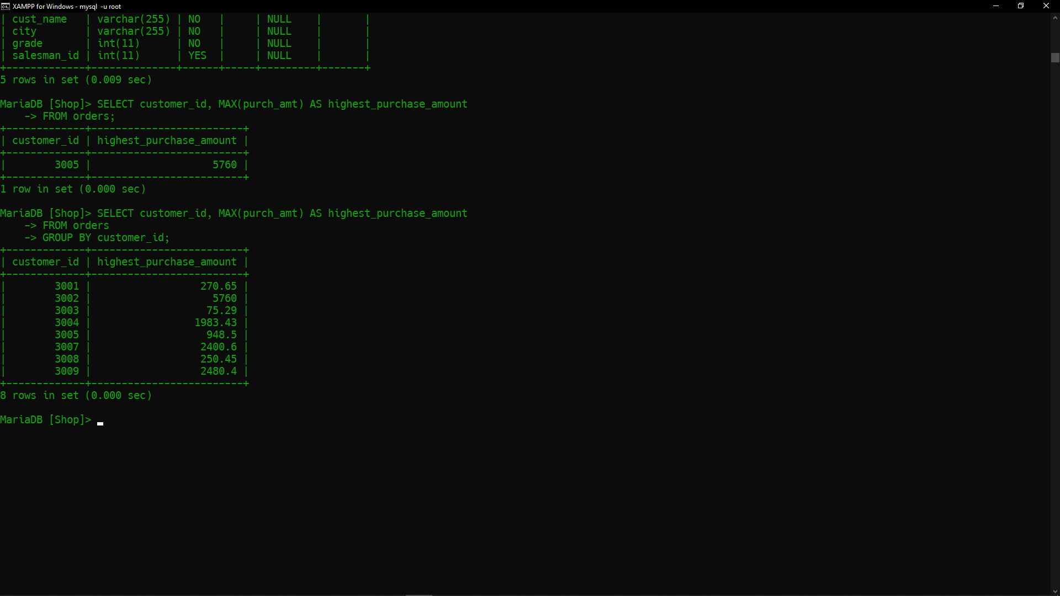
-> GROUP BY customer_id;

- Write a SQL statement to find the highest purchase amount ordered by each customer on a particular date with their ID, order date and highest purchase amount.
Ans: -> SELECT customer_id, ord_date, MAX(purch_amt) AS highest_purchase_amount
-> FROM orders
-> GROUP BY customer_id, ord_date;
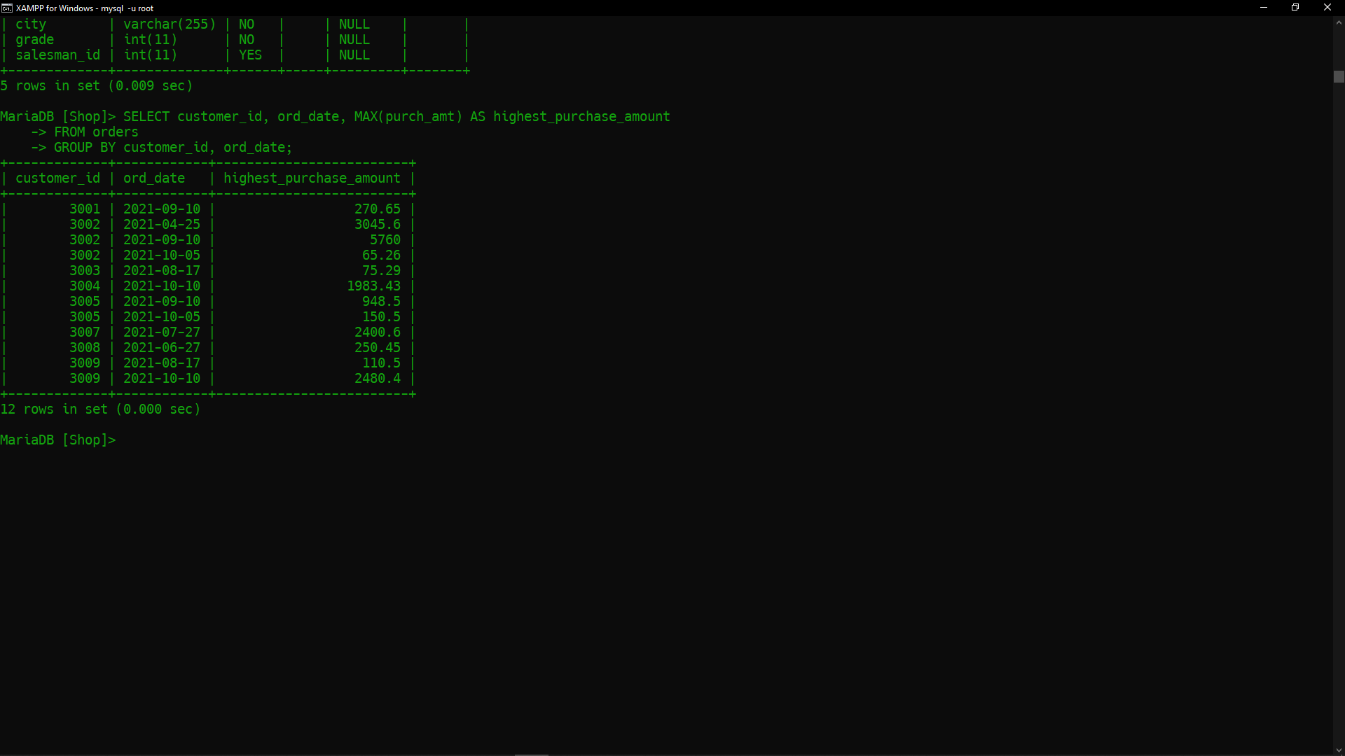

- Write a SQL statement to find the highest purchase amount on a date '2021-08-17' for each salesman with their ID.
Ans: -> SELECT salesman_id,MAX(purch_amt) AS highest_purchese_amount
-> FROM orders
-> WHERE ord_date = ‘2021-08-17’
-> GROUP BY salesman_id;


- Write a SQL statement to find the highest purchase amount with their ID and order date, for only those customers who have highest purchase amount in a day is more than 2000.
Ans: -> SELECT customer_id, Ord_date, MAX(purch_amt) AS highest_purchase_amount
-> FROM orders
-> GROUP BY customer_id, ord_date
-> HAVING MAX(purch_amt) > 2000;
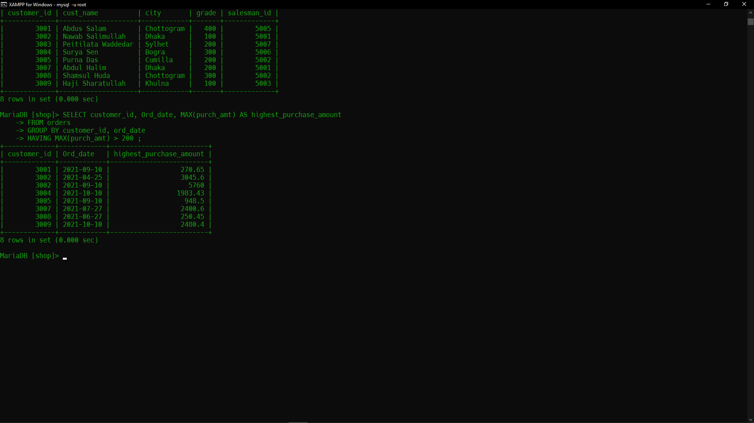

- Write a SQL statement to find the highest purchase amount with their ID and order date, for those customers who have a higher purchase amount in a day is within the range 2000 and 6000.
Ans: -> SELECT customer_id, ord_date, MAX(purch_amt) AS highest_purchase_amount
-> FROM orders
-> GROUP BY customer_id, ord_date
-> HAVING MAX(Purch_amt) BETWEEN 2000 AND 6000;
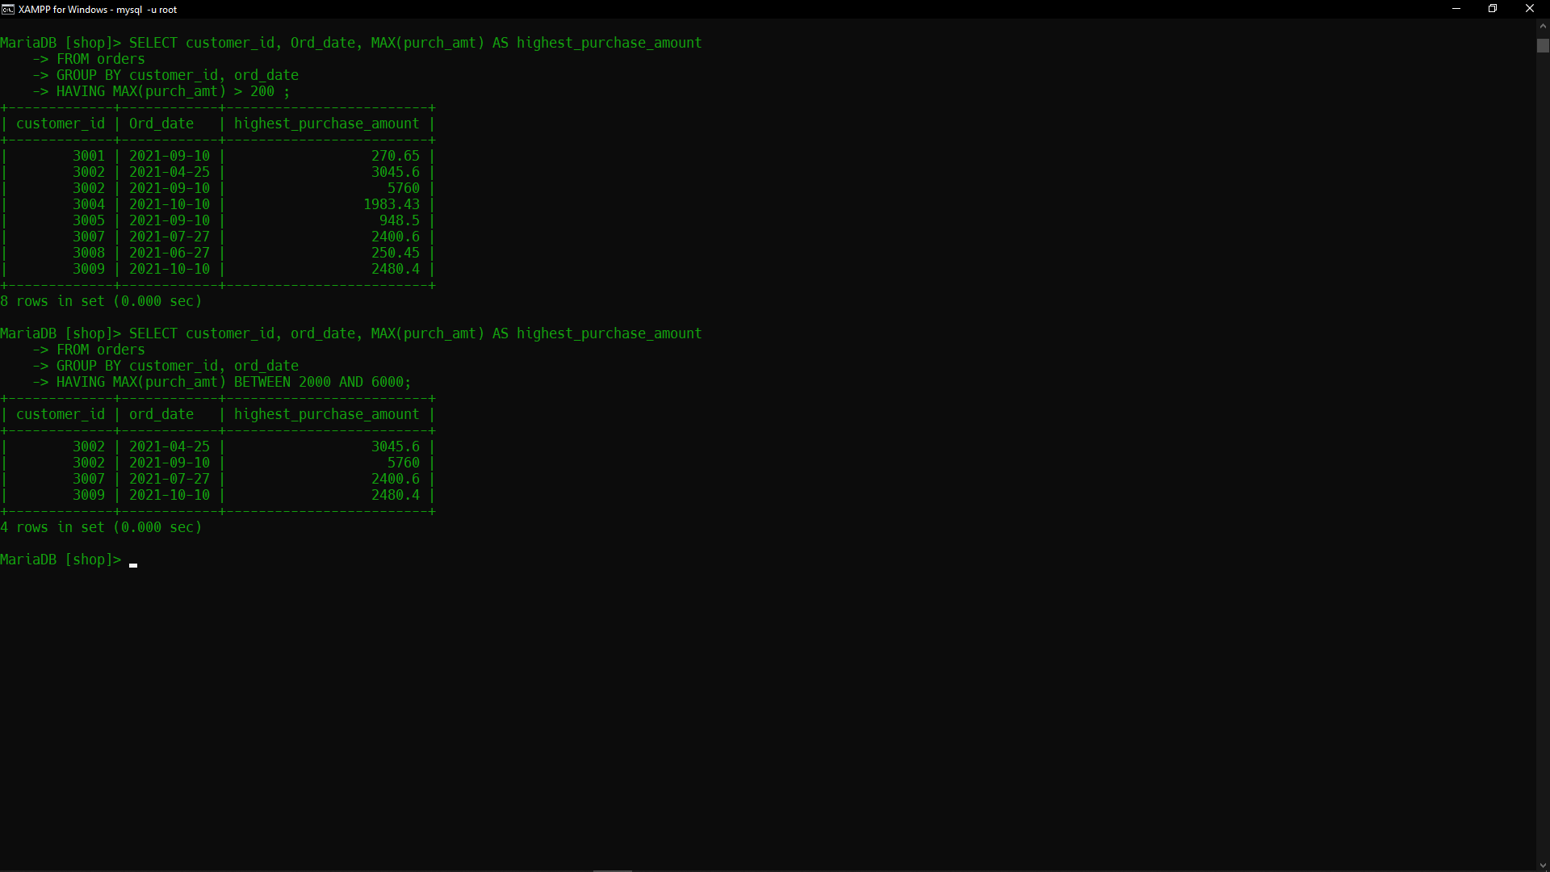

- Write a SQL statement to find the highest purchase amount with their ID and order date, for only those customers who have a higher purchase amount in a day is within the list 2000, 3000, 5760 and 6000.
Ans: -> SELECT customer_id, ord_date, MAX(purch_amt) AS highest_purchase_amount
-> FROM orders
-> GROUP BY customer_id, ord_date
-> HAVING MAX(purch_amt) IN (2000, 3000, 5760, 6000);
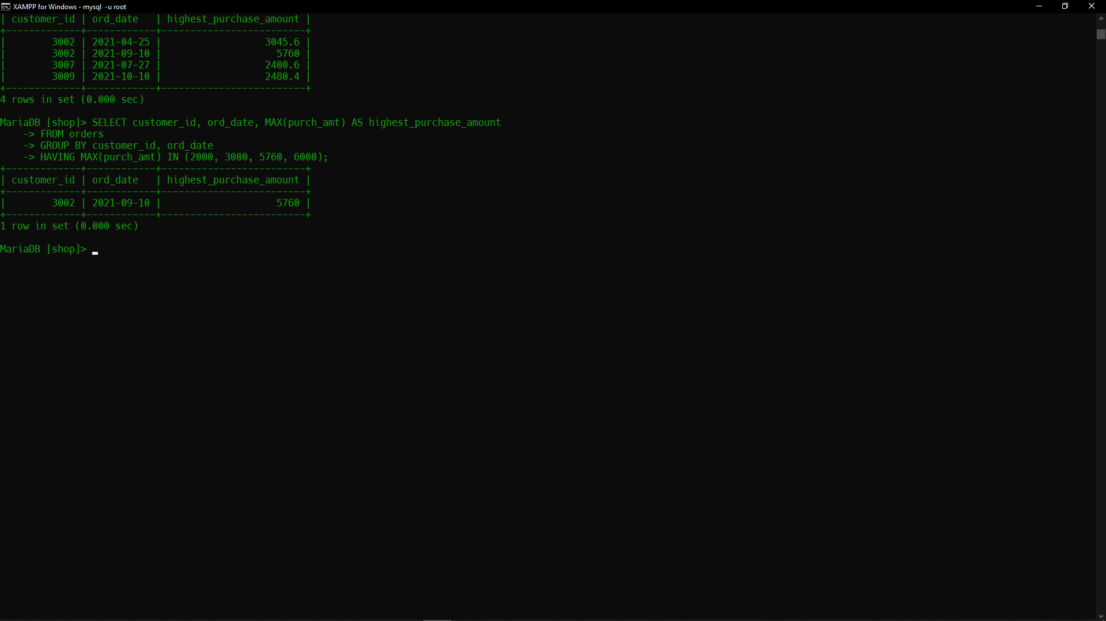

- Write a SQL statement to find the highest purchase amount with their ID, for only those customers whose ID is within the range 3002 and 3007.
Ans: -> SELECT customer_id, MAX(purch_amt) AS highest_purchase_amount
-> FROM orders
-> WHERE customer_id BETWEEN 3002 AND 3007
-> GROUP BY customer_id;


- Write a SQL statement to display customer details (ID and purchase amount) whose IDs are within the range 3002 and 3007 and highest purchase amount is more than 1000.
Ans: -> SELECT customer_id, MAX(purch_amt) AS highest_purchase_amount
-> FROM orders
-> WHERE customer_id BETWEEN 3002 AND 3007
-> GROUP BY customer_id
-> HAVING MAX(purch_amt) > 1000;
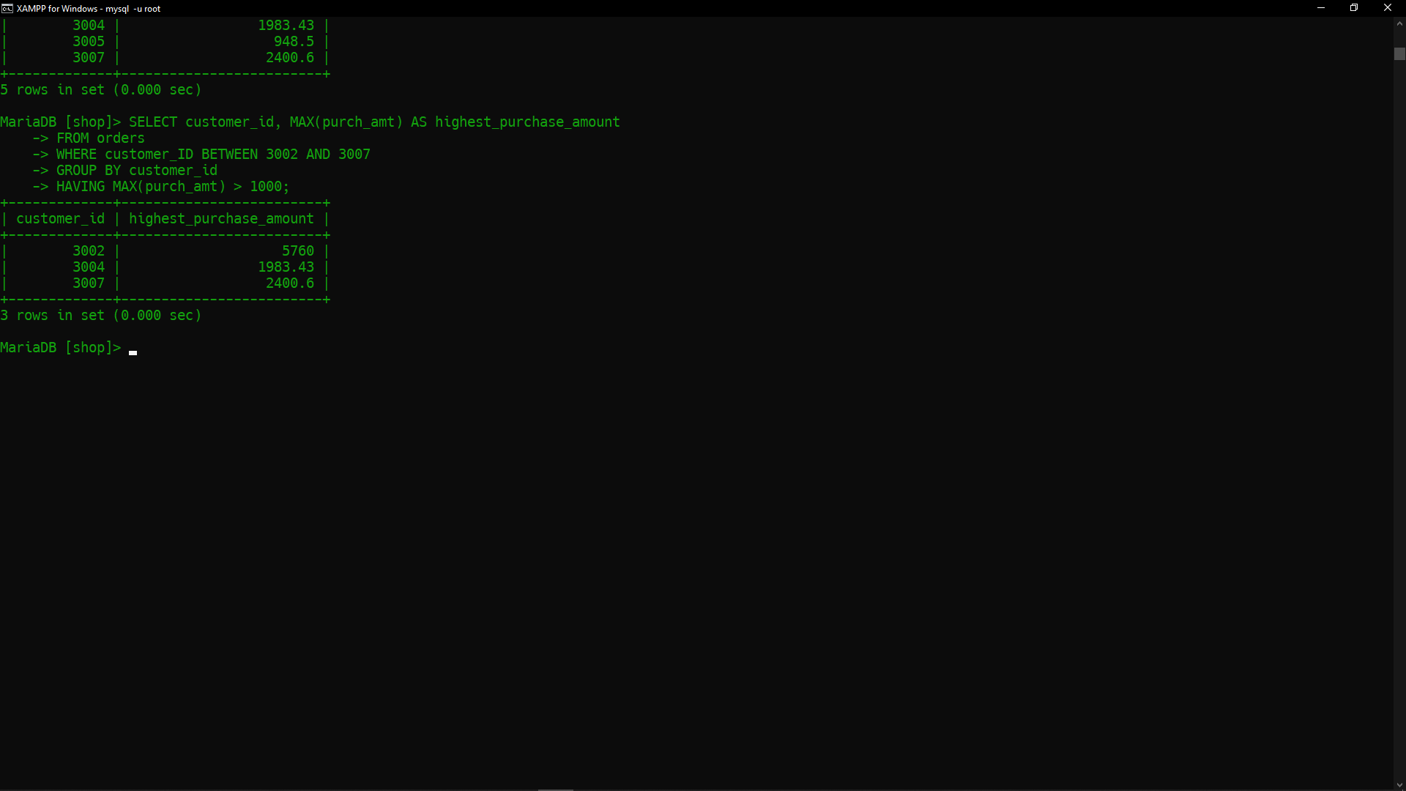

- Write a SQL statement to find the highest purchase amount with their ID, for only those salesmen whose ID is within the range 5003 and 5008.
Ans: -> SELECT salesnman_id, MAX(purch_amt) AS highest_purchase_amount
-> FROM orders
-> WHERE salesman_id BETWEEN 5003 AND 5008
-> GROUP BY salesman_id;
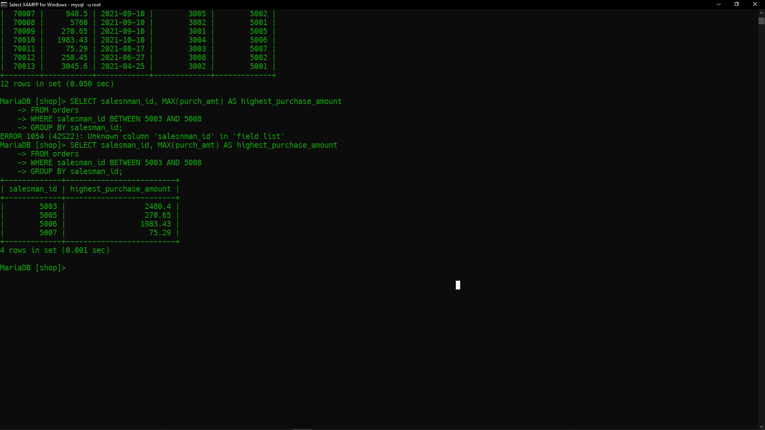

- Write an SQL statement that counts all orders for the date August 17th, 2021.
Ans: -> SELECT COUNT(*) AS order_count
-> FROM orders
-> WHERE ord_date = '2021-08-17';


- Write a SQL statement that count the number of salesmen for whom a city is specified. Note that there may be spaces or no spaces in the city column if no city is specified.
Ans: ->

- Write a query that counts the number of salesmen with their order date and ID registering orders for each day.
Ans: -> SELECT ord_date, salesman_id, COUNT(DISTINCT salesman_id) AS num_salesman
-> FROM orders
-> GROUP BY ord_date, salesman_id;
